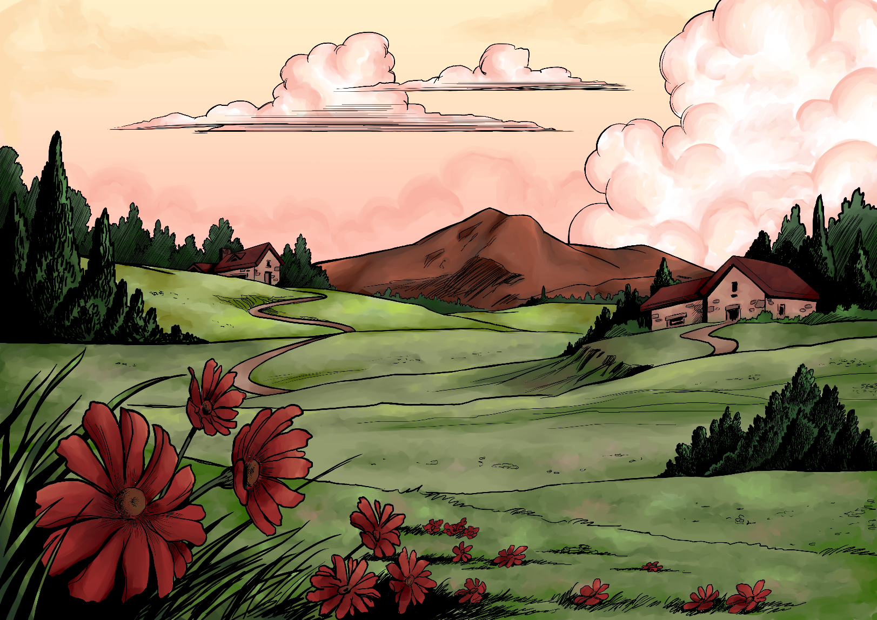

**Millennial Missions—Topic 3: Living Space**

**What God’s way is, and what He promises to those that love Him and follow in His way:**

“And God said, Let the waters under the heaven be gathered together unto one place, and let the dry land appear: and it was so.And God called the dry land Earth; ...and God saw that it was good. And God said, Let the earth bring forth grass, the herb yielding seed, and the fruit tree yielding fruit after his kind, whose seed is in itself, upon the earth: and it was so.**...**God saw that it was good.” (Genesis 1:9-12)

“The Lord God had not caused it to rain upon the earth, and there was not a man to till the ground. But there went up a mist from the earth, and watered the whole face of the ground. And out of the ground made the Lord God to grow every tree that is pleasant to the sight, and good for food; … And a river went out of Eden to water the garden.” (Genesis 2:4-6, 9-10)

The earth is the Lord's, and the fulness thereof; the world, and they that dwell therein. (Psalm 24:1)

**What God’s Word warned would happen, because people have chosen to disobey God and allowed evil into their lives:**

*[A worldwide flood took place and changed the way the world is, with much more ocean area, less land, and harsher climates and weather.]*

And, behold, I, even I, do bring a flood of waters upon the earth, to destroy all flesh, wherein is the breath of life, from under heaven; and every thing that is in the earth shall die. But with thee will I establish my covenant; and thou shalt come into the ark, thou, and thy sons, and thy wife, and thy sons' wives with thee. …

And God remembered Noah, and every living thing, and all the cattle that was with him in the ark: and God made a wind to pass over the earth, and the waters asswaged;

The fountains also of the deep and the windows of heaven were stopped, and the rain from heaven was restrained. (Selected from Genesis 6:11-18; 8:1-5, 21-22; 9:1-2)

Because of swearing the land mourneth; the pleasant places of the wilderness are dried up, and their course is evil, and their force is not right.For both prophet and priest are profane; yea, in my house have I found their wickedness, saith the Lord. (Jeremiah 23:10-11)

And Lot lifted up his eyes, and beheld all the plain of Jordan, that it was well watered every where, before the LORD destroyed Sodom and Gomorrah, even as the garden of the LORD, like the land of Egypt, as thou comest unto Zoar. (Genesis 13:10)

Then the LORD rained upon Sodom and upon Gomorrah brimstone and fire from the LORD out of heaven; And he overthrew those cities, and all the plain, and all the inhabitants of the cities, and that which grew upon the ground. (Genesis 19:24-25)

As in the overthrow of Sodom and Gomorrah and the neighbour cities thereof, saith the LORD, no man shall abide there, neither shall a son of man dwell in it. (Jeremiah 49:18)

**What God tells us to do about the problem for now, until the time is right for Him to make everything nice on Earth:**

*[Turn back to God and pray: ]* If I shut up heaven that there be no rain, or if I command the locust to devour the land, or if I send pestilence among my people; If my people, which are called by my name, shall humble themselves, and pray, and seek my face, and turn from their wicked ways; then will I hear from heaven, and will forgive their sin, and will heal their land. (2 Chronicles 7:13-14)

Enlarge the place of thy tent, and let them stretch forth the curtains of thine habitations: spare not, lengthen thy cords, and strengthen thy stakes.(Isaiah 54:2)

Bring the poor that are cast out to thy house. (Isaiah 58:7)

Wait on the Lord, and keep his way, and he shall exalt thee to inherit the land. (Psalm 37:34)

**What might it be like on Earth during the 1,000 year time at the end of this world’s History, when the world is renewed and refreshed and Jesus Christ rules as King over all:**

Blessed are the meek: for they shall inherit the earth. (Matthew 5:5)

The wilderness and the solitary place shall be glad for them; and the desert shall rejoice, and blossom as the rose. Then shall the lame man leap as an hart, and the tongue of the dumb sing: for in the wilderness shall waters break out, and streams in the desert.And the parched ground shall become a pool, and the thirsty land springs of water: in the habitation of dragons, where each lay, shall be grass with reeds and rushes. (Isaiah 35:1,6-7)

For the Lord shall comfort Zion: he will comfort all her waste places; and he will make her wilderness like Eden, and her desert like the garden of the Lord; joy and gladness shall be found therein, thanksgiving, and the voice of melody. (Isaiah 51:3)

**Promises for Princes and Princesses of God:**

Ask of me, and I shall give thee... the uttermost parts of the earth for thy possession. (Psalm 2:8)

The righteous shall inherit the land, and dwell therein for ever. (Psalm 37:29)

***

**Millennial Missions Stories**

*Imaginary Stories—taking place in the future time of the one thousand year “Millennium” that the Bible speaks of, when Jesus Christ rules all with love and justice, and the Earth is made pleasant again.*

* **Story 1--The Sad Old World: In Utter Anguish**

“Pound, pound, pound!” came the wrapping on the door, with each bang louder than the one before.

The children started to cry, and the mother’s face looked in utter anguish. They knew who it was. The neighbourhood’s most wealthy landowner was there to either collect the rent for the past few months, or out they would have to be put. He owned most of the houses around there, and was making an unnecessary fortune on the struggling community.

“Mommy!” the children ran and hid indoors, hoping it would save them. They no longer had neighbours—until new tenants would be found who could afford the greedy rental fees. This family knew they were next. Never mind that it was mid-winter, and the house would most likely remain vacant, for some weeks or months after they were ousted.

“I’ve come to collect the rent you owe me. Mercifully I have allowed you to remain here, since your husband passed away three months ago. But there comes a time for reckoning, and that time is now. Pay up, or join your neighbours in securing a more suitable location for the likes of you,” the icy words were spoken.

Knowing there was no way for her to do so, the mother, broken hearted and shattered simply said, “When are we to be out by?”

“This afternoon wouldn’t be too soon, but seeing that you have little ones, who would freeze their life away out here, I’ll kindly let you stay until after next weekend. If the payment hasn’t come to me by then, I will expect a vacant house that I can fill with those who deserve to stay here,” the landlord said, and continued on his rounds of the area.

He’d heard of a shipment of people coming one of these months soon to find living quarters nearby, and he was going to be ready, with plenty of accommodation to welcome them. Since they were government paid workers, they certainly could afford the rental fees—and maybe upped a bit from what it had been.

His mind was a walking calculator, and the numbers he was coming up with were tickling his fancies.

After a light meal, the family began to pack up the belongings they still had, into a few crates —after having to sell most else to buy food to eat.

To keep their courage up, the mother decided to play a game. They chatted about all the types of places they would love to live in. Some told of orchards of endless ripe fruit that was theirs to enjoy. Some told of huge mansions that they never had to pay rent for. Mother dreamed of a lovely little cottage down by a crystal clear stream, with a meadow for some sheep and cattle to graze on. It was nice thinking about these things.

But as the fire burned low for the night, as they drifted off to sleep, they knew their hopes would vanish, when just within days they would have no roof over their head at all.

Two days later, the evening before they were to leave, a friendlier knock came to their door. A pastor and his wife from a nearby district had heard about the ousting and evicting effort being undertaken around the area.

“We’ve come to bring some supplies for you, dear ones. And to offer you a place to stay on our property, until something can be worked out, perhaps with other relations of yours. There is a place that has been fixed up for a visitor’s abode. It’s currently unoccupied. Please come and stay with us, until better accommodations can be worked out.”

A map was given to this family, and the crates that had been packed up were loaded onto the pastor’s wagon.

As the mother held her little ones that night, a smile was on her face. Though things were not perfect, they were cared for—in the nick of time. One step at a time they’d be alright.

* **Story 2—The 1000 year Reign of Jesus Christ as King over all the world: Mr. Harthaven’s Grand estate—Part 2**

(Continued from Story 2 in *Millennial Missions—Booklet 2_Friendly animals*: “Mr. Harthaven’s Grand estate—Part 1”)

Elaine and Metilda took a stroll in the late afternoon around their family’s large estate. It wasn’t just their living place that was large because they were granted it from the King of kings, due to their honest hearts and kind ways, but most people seemed to have something similar around there. After all, the King needed people to look after His world, and who would do it best but those who had had so little chance to while they tried to live peacefully in humility.

When in the old world, if this family had the chance, they would have tended to crops, cared for the animals, and shared what goods their land produced with those in need. But due to economic conditions, and the greed of those who wanted more and more, they never could live this dream.

When it was nearly time for the evening meal and the girls turned to go they heard someone say, “I thought I’d find you both here.” Their dad, always caring and making sure his grown, yet very lively and young-looking girls, where happy and had what they needed.

“Shall we walk home together? I was just out fixing the old shed that we use down here, and since I knew you’d come this way I thought to stop by. While we walk home, you can tell me all you’ve seen today. I’m in awe at the wonder of this place. Every day holds such beauty, my heart can’t help but sing praise to God the Creator of all, and to King Jesus for His loving and peaceful rule of the Earth now. For those who choose to follow in His way, living in the world now is a marvellous experience.”

Mr. Harthaven remembered, as did his girls, just what life here had been like where they lived in the old world. They didn’t often think about it now, as there were too many wonderful things to keep their minds busy. But every now and then scenes of what their hard life used to be like, would flash in their mind. In those times they would stop to praise the One who had changed all that now.

Instead of the noise of the rushing traffic by their tiny house that was wall to wall with zillions of other rickety abodes, now they hear the sound of the wind, the birds, and the stillness. Instead of yelling vendors on the street and at their doors, struggling for a few more coins to help their family survive another difficult day, the sounds of laughter is heard when they meet for a sumptuous feast that they are sharing with visiting travellers.

Instead of a pot or two to put some flowers in, attempting to brighten up their stuffy, mildewy house, the large open windows let in the natural light and with it the wide and vast view of gorgeous vegetation, as far as the eye can see. Instead of being evicted, or worse yet thrown in to prison or into a work house as some people in the past have endured for failure to pay the rent, they own the place and can live there freely for as long as they wish.

Instead of taking years waiting for permission to build this or that needed structure, the Heavenly Ambassadors that keep charge over that part of the country grant permission promptly if it seems sound and safe; and if not, they offer suggestions to make it the best, so work can start as soon as possible.

As Elaine and Metilda together with Mr. Harthaven walked up the long winding pathway leading to their large and lovely estate atop a hill that overlooks the lush and vast land all around, they offered words of praise to God. They said how glad they were that this place that had formerly been a dry and parched desert, was now green and well-watered; with ponds, lakes and streams here and there.

They were so glad for the friendliness of the animals to one another. They were so happy for their large and lovely property and pleasant home. They were glad that they could stay there, rather than either being crammed in a dirty abode, or constantly roaming through desert lands in search of food for themselves and their animals--as some of their ancestors who lived around there in times past had to do.

This family now didn’t have to stay in a hot, fly pestered shack, that did little to keep the heat or the cold away. They were glad that they could walk barefoot, as their relatives had often done, but this time there were no biting bugs, snakes, nor thorns to step on. The soft grass welcomed their feet, treating them with care.

They were glad for the awesome view. No longer was this area just dry and topped with desert sand going on and on, with the few hardy dull coloured plants growing along the ground; there was so much variety now.

They could have gone on with their voices filled with gratitude, but they’d arrived at the little white fence that marked the inner garden of their house. Even though they were free to use and roam through the surrounding area, this lovely area atop the hill was their “home”.

Nesty, their cat was here to greet them, along with young Huda, a new comer they had invited to stay and live with them—along with her family. Since this place was no longer a desert, more families had begun to move here, away from other countries that had many people and who wanted more space to live and farm on and enjoy living with their families. It was the King’s plan that people have plenty of land to live on, with abundant food and resources.

Huda and her family came on a sailing vessel a few years earlier, from her former home in the south of India. Her children were born into the new world. They had never known things quite as difficult as they had been before, but their grandfather with whom they had lived, before moving to this new land, used to tell them what it was like. He said,

“I grew up in a tiny house—if you could call it that. There were 14 of us living under one roof. There was no toilet in the house, but a shared outside pit with a wall built around it, was for our use. There was no running water, so we all would take turns bringing water from the muddy river a mile-and-a-half walk away.

“We slept side-by-side on the floor, which made the hot nights even harder to manage. When you moved it would disturb the one beside you. But sometimes you had to move or wiggle, as the biting insects would cause you to.

“We bathed in the river, and that was always the best part of the day. Splashing and laughing. It was so refreshing. But I used to dream of bathing in crystal clear waters. The water was always muddy, because it was always being used by the many thousands of people living in that small area, along with the water buffalo that liked to get washed too. Bugs didn’t only bother the humans; all the animals endured their own pests too. The difficulties of life then were many. But I had hope.

“And when King Jesus returned to take over the world, nothing has been the same again. Year by year things improve. We used to pray to gods we thought were in charge, but they were just vain imaginations and false teachings. Now we know the truth. I would have loved to know it back then, but God has granted us the privilege to live to see the day when His Son Jesus rules at last, in truth and justice. In true righteousness, bringing peace at last.”

The large estate that Mr. Harthaven owned now, after living in poverty for so many years, felt like he was now a king. There was still work to be done, and everyone was kept busy adding their skills to make this small community a place where all had what they needed.

Since the time when the first ambassadors from the King of kings had visited him and granted him permission to live here and be in charge of this part of the land, he always made sure to show his respect to the King of all.

Every night and again each morning the families meet for praise and worship, and reading messages from God’s Word given to them over the years by those visiting from the Heavenly City.

After knowing how wrong things can get when humans try to pursue their own interests rather than respecting and following God’s ways, he wanted to start this part of the country the right way. If their small but growing community started things right, humbly realizing their need for God, then things could continue to get better and better.

Around a banquet sized table sat all the members of Mr. Harthaven’s family as well as Huda’s family, and a team of visitors just passing through the area, to eat the evening meal together. On the table were vases filled with the bright and lovely flowers that Elaine and Metilda had picked. Mr. Hartheaven sitting at the head of the table led everyone in a prayer of thanksgiving, as they ended their day,

Everyone bowed their heads respectfully, and even the cat that had been under the table, weaving in and out around the legs of those there, stopped to sit for the prayer.

“Lord of all, God of Heaven, King of the Earth and Universe and all that there in is, we praise You—and always will. Amen.”

***

Unbeknownst to Mr. Harthaven and the others, the two travelling visitors were no ordinary ones. On the outside they looked, talked and appeared to be just like those who lived in the south of the country. But before they left to continue on their journey and exploration, they revealed to Mr. Harthaven something wonderful that brought tears to his eyes.

They handed him a letter—a letter that they said was from the King Himself. They said they were members of His personal team and had come from Heaven to see how he and his family were faring, and to see if their hearts had turned to God and surrendered to the rule of Jesus Christ.

“You are doing well, and our King is pleased,” the visitors gave him a farewell embrace, handed him the special letter that looked more like a small book, and then inexplicably vanished.

Mr. Harthaven knelt down, crying tears of gratitude, and was in awe and wonder. It was some time before he had the composure to call his personal family together to tell them what had happened.

Of course everyone was very eager to read what was written, and could hardly wait a moment. Thanks to a travelling teacher who had stayed with them some years back for a few months, everyone had learned to read and thus could review the messages that had been passed on to them—and everyone around.

It was a way to be reminded of the ways and Words from the King of kings was vital to their success. It would help them succeed in having happy and thriving, peaceful and good communities, towns and countries.

This book turned out to be the latest edition of a manual that was being given out personally, to those worthy; those who would act upon the words written therein. It told of the King’s plan for making things in that area the best they could be. It told rules and guidelines what would bring the fastest progress to making things the happiest they could be.

Those who were ready to learn the ways of the King of the universe were permitted to read and study it, and would be allowed to attend a special meeting of the tribes sometime in the not too distant future, to see how and if it was being implemented, and to discuss challenges they faced.

Mr. Harthaven felt very honoured to have his little community be some of the first ones that the King of all was giving this special responsibility too. The Lord had indeed given him much, and he want to give to the Lord all he could, in doing the best for the world around them—the new and improving world.

* **Story 3—Heavenly Ambassadors and Angels Living with Jesus Christ and Reigning with Him over the world: Glad to be in the Ruling Family**

“*This area here—what was once a country you served Me in—is yours to rule. In love and righteousness, and in teamwork with Me of course, you dear and faithful ones, will rule and oversee it. You will be My ambassadors, My Princes and Princesses, My representatives; the head ones in charge of its land and Earthly citizens, and I will expect you to answer to Me on all matters concerning this part of My Kingdom*.”

Jesus the King announced to the special team that was standing before Him in the courts of His celestial palace. A greater honour couldn’t be given.

They were ones who had been very faithful to do their best to bring the people of this country to know Jesus. They had endured many troubles doing so. Most of them didn’t have a house to call their own, as they travelled around spreading the good news of the Gospel to whoever would listen.

Now they had the pick of anything in the country. If they wanted use of an ancient castle—or wanted to build one—they could. If they wanted a whole village of houses to be available for their families while they visited and looked after things in the country, that was their’s to have. If they wanted the mountain range solely for their use, that was up to them. It was all theirs—along with the others they were to teamwork with.

Of course, the Earth was the Lord’s and all that was in it, but they were to be as stewards over it, and do their best to teach and train those living there. It was of course a massive job, but with the fulltime assistance of the King, and all the angels sent to aid them, it wouldn’t be too hard.

“Talk about expanded living quarters!” one man said to one of the ladies also on the ruling team.

“Not only do we have the most spacious and fabulous living space in our Heavenly abode, but we also have vast lands to dwell in while we continue working for Jesus on Earth. This is granted to those who loved Jesus and were faithful to do His work while on Earth before. We’ve been given so much in return for having given up lands and houses, or didn’t spend our days working to acquire them, so that we could instead fully focus on setting things up for the King, before He returned,” she responded.

They were all in utter amazement, and it took some time for the full impact of the mission and the great gift and honour to sink in. There was lots to think about, and lots to plan.

One of the members restated what Jesus had said, as they met for a meeting to begin planning, “He said any building we’ve always wanted to build, any type of city we’ve wanted to set up while on Earth for His glory, we now have permission and all the supplies given to us to do it—and the workers to help. Those who will be living there and benefiting from our teaching and training programs, can be employed and put to work for us now, doing something positive at last for the country. What a thrill this will be!”

One of them planned a huge estate that would house many of the country’s citizens—those who wanted to be trained in living as loving citizens of the King of kings. In a way it was like a large learning facility, but nothing like those in the old world, with small rooms and stale air. This one would be very different, and God’s Word was the main text book to be studied, along with learning about the lives of many people who had loved and served God throughout the history of the world.

A heavenly lady fancied setting up the riverside, and surrounding hills as her base. Women from all over the country who wanted to learn the art of motherhood could bring their littlest ones and enjoy the beautiful area, read, have classes by the river, talk, and enjoy a week or two at a time, living and learning about how to care best for their children. They could learn about the best kinds of foods to eat, and how to take care of themselves physically so to maintain good health and strength.

A princely man on the team wanted to oversee a large agricultural area of the country. His mission was to train young people in the art of Godly food growing. Since the land produced so much better than it ever did before in the old world, it wasn’t all that much work, at least compared to old world conditions. But it was a good skill to know, and if they wanted certain foods to be grown, ones that didn’t spring up naturally, they needed to put some work into it.

Another heavenly ruler of the team wanted to oversee the port and main coastline area. There ships would be built, and cruises of the islands could be enjoyed. The beaches would need some serious clean up, and would no longer be the places of pollution as they had been before. While on the ships, this man would be able to teach those travelling all about the ways of the “man of Galilee”, Jesus Christ, and help them learn His ways—some things that He taught while standing on a boat.

Another lady said, “I think I’d enjoy travelling around, and not just remain at a certain base, that way I can take children from the Heavenly City for trips around the country. They could learn about it, and also help to teach the children of this country about what it means to be a loyal citizen of the most loving King of all, the one who does all thing right and good for all. –And me and those I’m with could come and stay with each of you for a little while, while we travel around. I like the concept of ‘all the land lieth before you’ as was told to a team many years ago.”

Everyone nodded and thought it sounded great. They would finish writing their initial plans up, and present them to the King for His approval and suggestions. Together with Him, the country was going to get better by the day. If they thought they didn’t have much room to move, or housing was hard to come up with, this was more than making up for it. The Earth really was the Lord’s. They were glad to be in the ruling family of God.

**Written by:** Chariane Quille

**Illustrated by:** Philippe

 www.nurture-inspire-teach.com

