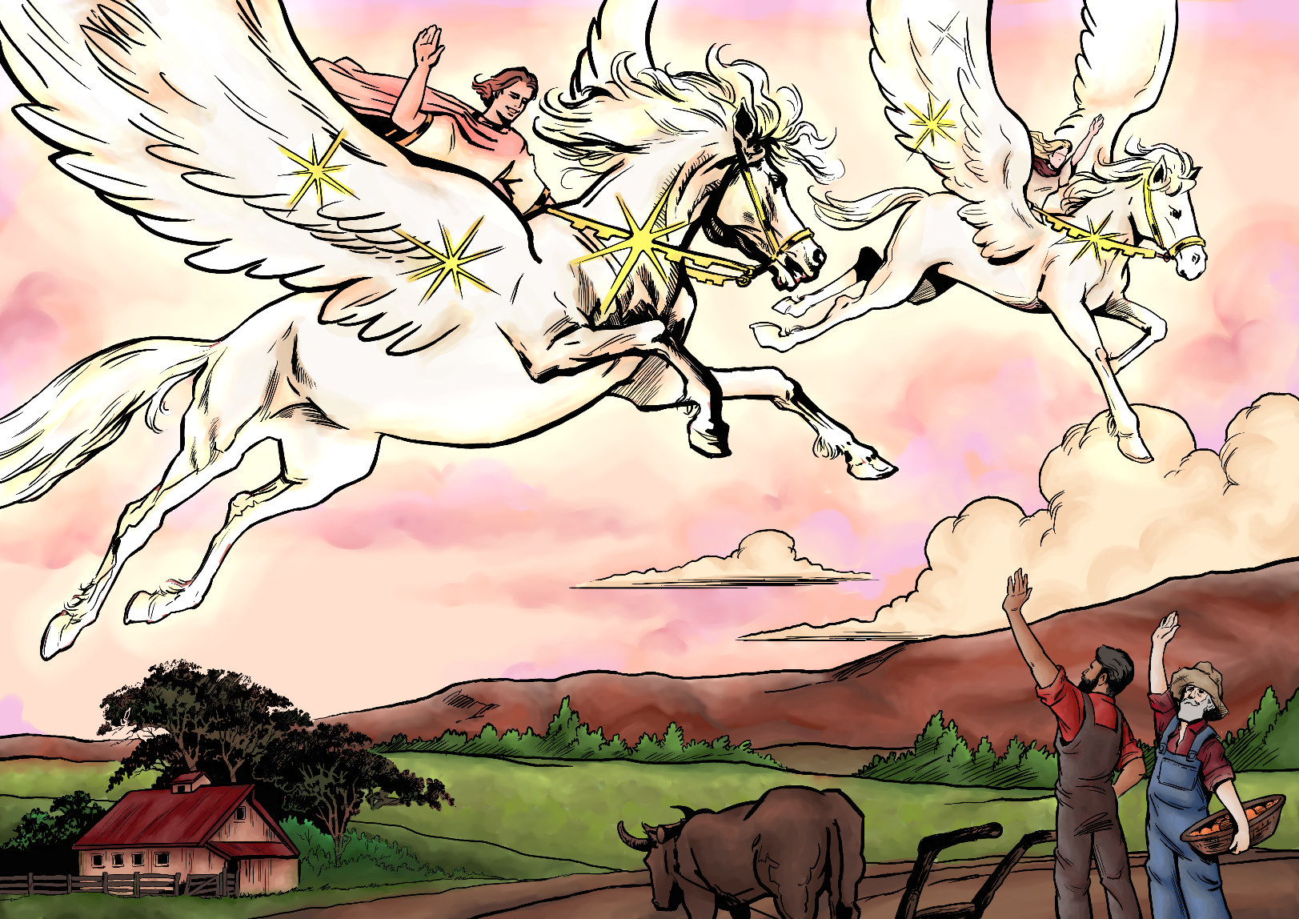

**Millennial Missions—Topic 4: Peace on Earth**

**What God’s way is, and what He promises to those that love Him and follow in His way:**

Blessed are the peacemakers: for they shall be called the children of God. (Matthew 5:9)

And above all things have fervent charity among yourselves: for charity shall cover the multitude of sins.Use hospitality one to another without grudging. (1 Peter 4:8-9)

**What God’s Word warned would happen, because people have chosen to disobey God and allowed evil into their lives:**

Repent; or else I will come unto thee quickly, and will fight against them with the sword of my mouth. (Revelation 2:16)

The earth also was corrupt before God, and the earth was filled with violence. And God looked upon the earth, and, behold, it was corrupt; for all flesh had corrupted his way upon the earth. And God said unto Noah, The end of all flesh is come before me; for the earth is filled with violence through them; and, behold, I will destroy them with the earth. (Genesis 6:11-13)

The imagination of man's heart is evil from his youth… (Genesis 8:21)

**What God tells us to do about the problem for now, until the time is right for Him to make everything nice on Earth:**

If it be possible, as much as lieth in you, live peaceably with all men.

Dearly beloved, avenge not yourselves, but rather give place unto wrath [God’s punishment]: for it is written, Vengeance is mine; I will repay, saith the Lord.

Be not overcome of evil, but overcome evil with good. (Romans 12:18-21)

Then said Jesus unto him, Put up again thy sword into his place: for all they that take the sword shall perish with the sword. Thinkest thou that I cannot now pray to my Father, and he shall presently give me more than twelve legions of angels? (Matthew 26:52-53)

**What might it be like on Earth during the 1,000 year time at the end of this world’s History, when the world is renewed and refreshed and Jesus Christ rules as King over all:**

And he shall judge among many people, and rebuke strong nations afar off; and they shall beat their swords into plowshares, and their spears into pruninghooks: nation shall not lift up a sword against nation, neither shall they learn war any more.

But they shall sit every man under his vine and under his fig tree; and none shall make them afraid: for the mouth of the LORD of hosts hath spoken it. (Micah 4:3-4)

**Promises for Princes and Princesses of God:**

He that hath an ear, let him hear what the Spirit saith unto the churches; He that overcometh shall not be hurt of the second death. (Revelation 2:11)

And out of his mouth goeth a sharp sword, that with it he should smite the nations: and he shall rule them with a rod of iron:

And he hath on his vesture and on his thigh a name written, KING OF KINGS, AND LORD OF LORDS. (Revelation 19:15-16)

The whole earth is at rest, and is quiet: they break forth into singing. (Isaiah 14:7)

***

**Millennial Missions Stories**

*Imaginary Stories—taking place in the future time of the one thousand year “Millennium” that the Bible speaks of, when Jesus Christ rules all with love and justice, and the Earth is made pleasant again.*

* **Story 1—The Sad Old World: Running to Escape**

“Mommy, why do we have to run so far way, and leave our home?” the exhausted girl cried breathlessly as they—what was left of their family—finally arrived in the dark in a little forest.

“Mama, I am very, very thirsty,” a boy said. He had been running to escape the violence that had broken out in the area he lived. There were explosions and death and destruction everywhere.

Now they were going to face a very cold, hungry and uncomfortable night.

There was nothing to eat or drink. They had to escape so quickly, to save their lives, there was no time to grab needed supplies. Even if they had, they would have been used up by now.

Then the crying started, as the trauma of the past two days set in.

“Mama, I feel so cold... and I miss Papa...” a little one broke down in tears, followed by most everyone else.

In two more days they would reach the boarder to cross over to a place where they could rest in peace, they hoped.

When night fell, a sort of calm settled, and the utterly exhausted family slept restlessly, huddled together.

The older boy happened to have a plastic bag in his pocket, and early the next morning he cleverly went around to the plants and trees and was able to shake some dew into the bag. He shared it around, and did this until all had had a sip of water.

“Mama, look!” said one of the girls, “A dandelion!”

“Go ahead dear, there might be a few others, see what you can find,” mother said.

So the children went around to find their “breakfast”. Though rather bitter, it was better than having nothing at all. They ate some of the leaves and flowers, and collected a bit more dew before it dried up.

“We should start our walk soon, we have a long way to go, and we don’t want anyone to stop us yet.”

And so with aching muscles and shaking hearts, the tearful team carried on, only to be met with trouble again. As they were walking along at a brisk pace they heard and felt an explosion. A landmine had gone off close by, and now there were injuries to deal with.

This was more than the mother could take.

“Why does there have to be war and violence with people against people? Aren’t we the same race—all from a common ancestor? Why can’t we help each other make it through life?”

Mother cried long and hard. There was nothing to do to stop the bleeding of the wounds. They couldn’t move ahead, unless some help came.

Though injured, the boy decided to collect some thin logs and to make some short of a structure that they could cover with foliage and rest inside, to give them some short of protection and shelter.

Some leaves were gathered, and the family lay in what seemed to possibly be their final resting place.

Mother had torn off some of her tattered dress to bind up some of the torn skin that the shrapnel had made when it grazed. It’s true that they could be worse off, but it wasn’t easy in anyway.

Their home long gone and utterly in a ruinous heap. Their family was also broken as war had taken the lives of her husband and oldest son and his wife and child. It was all because the land they lived on was now supposed to belong to some other type of people, who looked and lived and dressed and believed differently.

The long painful night, fraught with shivers and tears, seemed to last a lifetime, and caused everyone to remember their life, and all that had happened—the good and the bad. At last, when the sun’s rays began to emerge, mother hobbled over to try and collect a few sips of water.

She fell to her knees in pain—of heart and body, and in utter exhaustion.

“Dear God,” she finally prayed, “We’re sorry for letting ourselves and our country get so far away from the way You wish things to be. Those troubling us now are hardened to Your truth and wish no good for anyone but themselves.

“Even if I and my children die today, since there is no hope left for us, I want to do so knowing that we have turned to You, and want to make things right again. I was so wrapped up in living my little busy life, and occupied with material possessions that I rarely took time to read Your Word in the Bible. My children hardly know who You are. If You want to help us, please do so soon, as we don’t have much time left to live, it seems.”

When her teary eyes opened again, she looked up, not knowing what to expect next besides a lot of hardship. However, when she blinked she noticed suddenly that a bush was growing there was filled with berries, ripe and ready for eating. How they got there, and why they were not seen before, she didn’t know, nor did she care.

“Children! God has heard our prayers! He’s with us even in this terrible situation,” she exclaimed, and began to pick some of the delicious fruit, and place it in her hat.

She came to serve it to her young ones, who, for some reason were feeling particularly well.

“Mama, my cut doesn’t hurt anymore!” the girl said.

“Yummy berries!” they gratefully enjoyed, making sure that all got to have a fair share.

Then mother began singing a hymn that she knew parts of, and made up the rest to go along with the tune. Their hearts were glad, and somehow they knew they would be alright.

“I think we can travel today, mother” said the children. Though still hurting somewhat, just the joy of the miracle berries, and the general feeling of wellness that had come over them, gave them courage.

Suddenly, as if to dampen and scare this brave family’s courage, a large and extremely loud set of jets came roaring overhead. They fell into each other’s arms, shaking. They didn’t know what would follow. Yes, a very loud boom came before too long, and the whole ground seemed to rumble. The impact knocked not only their branch hut down all on them, but a few trees as well.

“I guess we have no choice now. We must go. Are you ready?” said mother pulling them all out of the rumble. The boy carried the youngest girl for awhile, and mother helped the other girl to use one of the large sticks of their rough abode as a sort of crutch, to hobble along at whatever pace they could.

“Let’s sing, children,” mother suggested. They did so for a while, but then the pains in mother’s stomach were too much. They had to rest for quite some time. However, they were nearly at a road by this time. One never knew who to trust, but at this point they would have been very glad for a lift in a vehicle.

The roar of a motor coming down the road made them all look up. They weren’t sure whether to hide or go and try to get the vehicle to stop. Even if the vehicle would let them in, would it be safe? No vehicle was, as they were often the targets of those disrupting the peace.

Mother took the brave step and stumbled closer to the road, waving a colourful scarf to draw attention. A jeep came down the broken road and stopped. It was almost too good to be true.

Driving the jeep was a man also leaving the area that she had lived in. He had plenty of his own troubles, losses, and pains. But he did have room, kind of, for this woman and her three children to squeeze in.

Once in, he offered them a piece of bread to share together, and a few sips of water, and off they drove. They felt much uncertainty. They didn’t know if they would safely make it across the boarder—and what would happen to them when they got there. But for now, they were moving forward and away from the hottest part of the troubles, and to them it was a miracle they were very grateful for.

* **Story 2—The 1000 year Reign of Jesus Christ as King over all the world: Making things Durable**

Hirato worked at the weapon processing factory. It wasn’t a place making them, but rather recycling them into farm equipment.

“Here comes another load,” Hirato said to his mate as they saw an approaching wagon. They rolled up their sleeves, put on their gloves, and got ready to carry crate after crate into the melting room.

Some would bring in all the ex-weapons, that had been smashed and destroyed first of all, before being brought into this facility. Others were working with the metals to melt down the right types and make rods and bars of metal.

Others would bring the solid metal blocks to the various buildings that were making all types of farm equipment—ploughs, shovels, rakes, harrows, wheel barrows, horse-driving tractors, irrigation pipes, axes, and hoes, to list a few.

The men learned the art of making things durable and strong, so they’d last a long time. If things weren’t made right, they would be returned and those men that built them would need to remake or fix them. To save time it was best that they did it the right way from the start.

New farms were starting up all over the country, and every new farm that was established was given a new set of tools and equipment to work with, free of any charge! --As all things were in this newly set up world. Not free of work and labour, for there was plenty to keep everyone happily busy, but there was no one rich and no one poor, they were all just citizens of God’s Earth who needed to help one another if they want things to go well.

“This sure is hard work! I’m regretting all the time I used to spend making them and, unfortunately using them in the old world,” said Hirato. He was learning the hard-work way, what God meant when His Word said, “Let the peace of God rule in your hearts” (Colossians 3:15) He and the others were part of the clean up crew, helping to make items that create—and make things grow, and to destroy that which destroyed, and broke things down.

Hirato wiped the sweat off his brow, as he sat under a tree for a break. He pulled out his favourite book—passages from the Bible that talked about God’s loving way to live, the way for things to stay at peace—and how unpeaceful things got when people decided to do things their own way.

He bowed his head to pray. He wanted to do whatever it took to make the world all at peace and at rest. He knew not everyone one around was of the same mind. Some still hadn’t learned to make God be their ruler, and wanted to take things into their own hands and gain control. They too would have to learn the hard way, just as all people of the past had to.

The world history was a long saga telling what happens if you do things the true ways of God, and the sad and sorry consequences for choosing a wrong path. He had faith that eventually everyone would learn to submit to the better ways of the King of all kings, and the Lord of all lords.

After a drink of water and a piece of fruit—and some hugs to go around to each one he was working with, Hirato was ready to get to work again. He was doing his part to make up for his wrongs, and to fix things as best as he and the others could, in order to bring peace and joy and beauty on Earth.

Sometimes as he worked, he cried a bit, as he remembered the sorrow that it caused the Lord who had created each of the people. He repented time and again, pouring out his heart to God, asking to be forgiven. But just because he still worked here to make things better, didn’t mean that he wasn’t forgiven.

Jesus had heard, but it just took some time until the damage would be fixed. If Hirato’s heart remained tender and repentant, it was a good state to be in, as then he did an enthusiastic job eliminating all the evil weaponry—and showing loving and brotherly kindness to those he worked alongside with.

Eventually the day came, the happy day, when he was told that because of his faithful and hard work here at the processing factory, he was now granted a farmland for his own! He could be trusted to run a place like that. He would use it for all the right life-giving things. This meant he could eventually have a family too, as he wanted to wait until he had a nice place for them to live.

Hirato knelt under that tree one last time on the last day of his work at the factory. “Thank You, Lord of life and Love, for granting me a new life.”

Then he cried a bit. His heart still ached at times for those whose lives had ended prematurely. Why had he been permitted to live on? But he was learning that God loved Him and had put his past behind. God was eager for Hirato to move on to new joys, to forget the past and build a new life. He needed to accept the Lord’s forgiveness and enjoy living in the ways of Heaven, as much as possible, while on Earth.

When Hirato looked up, he saw a lady standing there,

“Is this where I can get a rake for my garden?” she said. “I’m sorry to interrupt your time of contemplation.”

“Ah, yes, over there, in that large shed are the tools ready for taking...” Hirato answered and pointed.

He didn’t remember seeing her before. Perhaps she was new to this part of the country. But something about her looked, well, very peaceful. He would like to get to know her—and would assister her in any farming needs she had.

In time, as it worked out, the healing of Hirato’s heart was complete as he and this lady, Kentina, got to know each other more, and eventually moved in together to Hirato’s new farm. She had been staying with relatives, and hadn’t planned to live here. But that all changed as Hirato and her felt the fresh new love of the King of love blessing their lives.

Their farm flourished, as did their family of 12 children. Of course, not all at once. Over a period of 60 years they raised their family and built their farm. After that they began to watch a few grandchildren start to be added to their extending family.

And every day, without fail, Hirato met with his wife, then his wife and children, and then with all his family to read from God’s Word—the book that taught them how to live in peace and harmony, by knowing and loving and serving God above all.

***

* **Story 3—Heavenly Ambassadors and Angels Living with Jesus Christ and Reigning with Him over the world: The Prince of Peace Reigns**

Galloping and trotting through the clouds went the flying horses. Their riders were a team of young people who had been sent down on a mission to Earth.

These were not just any young people. These ones had known some really tough times. They had lived through the toughest time of world history—that time when it was forbidden to be a believer in Jesus Christ, who was now indeed the world ruler.

So many had lost their lives because of the hatred by the fierce enemies of God for those that maintained the conviction that the true God of Heaven was their Lord and Creator, and would return to take over the World at the appointed time.

This group of feisty young people didn’t care what anyone said or what anyone threatened to do to them. They were willing to have it cost their life, if that is what it took. They remembered the words of the Lord, that if they suffer with Jesus, they will rule and reign with Him. And now that’s what had happened.

When Jesus had returned in the clouds, they had flown up to the sky to meet their Lord and King who returned to get them. Some of the team members on horses today had their life shortened for a while, before Jesus’ return. But none of that mattered now. They all had been given super bodies that could do just about anything.

They couldn’t be in two places at one time, like Jesus can be anywhere, anytime. But they could fly, appear, disappear, change their appearance when needed, they could still eat and drink if they wished to—although they never were hungry or thirsty any more.

They could rest and relax when they wished, but they didn’t suffer tiredness and physical exhaustion. They enjoyed pleasures and fun, with enhanced senses to make things far more enjoyable than any on earth ever felt, and they had no physical pain or accidents or medical issues.

At last they were free—totally free! So free they felt they could fly through the stars! And often they did just that. They were free to love God in whatever ways they wished to, without anyone hindering them.

They were free to speak of Jesus and His power to anyone and everyone, and none could stop them. In fact, that is just what they were here to do today, and everyone had better listen.

Those who didn’t respect what these brave victors had to say, would be sorry. They would miss out on knowing things that would truly make them glad.

Those who didn’t listen and obey these ones who were helping to rule the world would have to answer to the King of kings and have to learn the hard way that it was best to believe and receive and enjoy the goodness that now was taking over the world.

Those that wished to keep doing their own and evil things, trying to rebel against God and His rule of love, would find things got pretty tough for them. For example, those on earth still needed food—and rain was needed to make it grow. However, it is God that sends the rain.

They need to honour Him and respect Him and do things in His loving way, or the rain might be withheld. Hunger would teach them to make the right choices, and not wish to stay selfish and greedy and proud. When any rebellious people would turn to the Lord again, in humility, wishing to obey His righteous ways, then the rain and well-growing crops would follow.

Down from the sky came the galloping team on heavenly horses. They were smiling and singing,

“All the world is at peace! The peace of God which passes understanding, shall keep your heart and mind. Peace be unto you! Peace on Earth, good will to men! Blessed are the peace makers, for they shall be called the children of God! The Prince of Life, the Prince of Peace reigns in love over all!”

Their anthem was sung out with hearty and loud voices.

Today the stories they would tell were going to show that God’s power is unmatched by anyone on Earth.

Although God prefers peace, He has the almighty power to do anything. He can use His power in the most spectacular ways. They could trust in Him, believe that He loves them, and respect Him. If they obeyed, things would go well. If they tried to go against the peaceful, unselfish, and kind ways of God, then they would regret it.

All they on Earth need to know more about God, and these ones who had lived through the effects of those who went their own stubborn way, could teach with conviction, that God’s way is always best, God’s way will endure forever, and God’s way will bring the greatest joy.

As the rumble of the horses hooves hit the ground running, the gathering people trembled. Soon the riders circled the crowd with their trotting horses. None dared move. And no one wish to.

This was the most exciting thing that had happened all week. No one wanted to miss the messages that would be given on this day.

As the Heavenly riders trotted around the standing crowd, they took turns talking to the people, passing on the messages that they came to deliver. After all was said, there was not a person in the crowd who was not weeping.

The message of how much the King of love cared about them, and had come down to Earth to give His life in order to win them, touched them deeply. The stories they told helped these people get to know Jesus in a personal way.

Then as the crowd knelt and bowed themselves in prayer, thanking God for His goodness and mercy, allowing them the new chance to live the right way on Earth, a wonderful thing happened.

A light was shining brightly down from the sky above, and a strong wind was beginning to blow. A sense of peace and joy flooded their souls.

When they all looked up, they saw the huge face of the King they were now serving and learning about, looking down at them. It was almost too bright to look at, but no one wanted to miss this amazing moment.

The Lord above seemed to say to each one of their hearts:

“Will you love each other, and tenderly care for each other—especially the young ones?”

And as the light faded to what the normal sky’s light would be, they all turned to each other, this way and that way, embracing, forgiving, encouraging and showing the love that their hearts had just been filled with.

Before the riding messengers left they said,

“This love in your hearts came directly from the King of Love Himself. Whenever you feel your own love waning and you need a fill-up, you know who to get it from. Just kneel down in humility, and ask the Lord of lords, Jesus Christ, to give You His love for one another, and He will.”

Off they rode, first galloping on the ground, then in the air, and then through the clouds, and they were gone from sight. The crowd sat there for some time watching and remembering what they had just experienced.

Then they determined that their town would be the friendliest one around, they’d learn the art, the skill of truly living in peace—down to the smallest child. Love would reign! –And so would the clouds, at just the right and needed times.

All would be at peace; and everyone would have the care needed. God would support with His provision all that was needed for each one living there.

**Written by:** Chariane Quille

**Illustrated by:** Philippe

 www.nurture-inspire-teach.com

