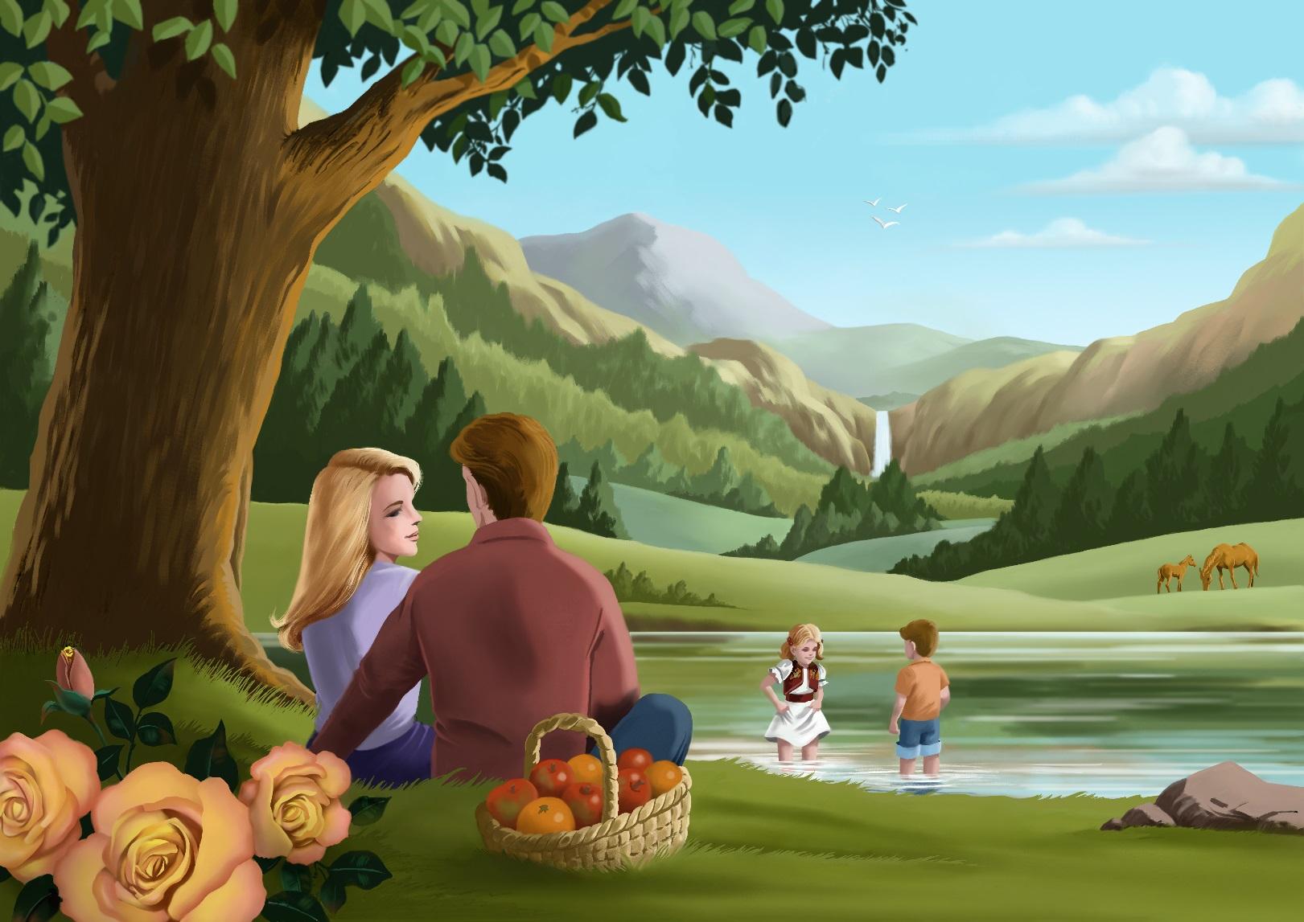

**Millennial Missions—Topic 6: Abundant clean water**

**What God’s way is, and what He promises to those that love Him and follow in His way:**

These are the generations of the heavens and of the earth when they were created, in the day that the LORD God made the earth and the heavens,

And every plant of the field before it was in the earth, and every herb of the field before it grew: for the LORD God had not caused it to rain upon the earth, and there was not a man to till the ground.

But there went up a mist from the earth, and watered the whole face of the ground. (Genesis 2:4-6)

And a river went out of Eden to water the garden; and from thence it was parted, and became into four heads.

The name of the first is Pison: that is it which compasseth the whole land of Havilah, where there is gold;

And the gold of that land is good: there is bdellium and the onyx stone.

And the name of the second river is Gihon: the same is it that compasseth the whole land of Ethiopia.

And the name of the third river is Hiddekel: that is it which goeth toward the east of Assyria. And the fourth river is Euphrates.

And the LORD God took the man, and put him into the garden of Eden to dress it and to keep it. (Genesis 2:10-15)

**What God’s Word warned would happen, because people have chosen to disobey God and allowed evil into their lives:**

And the LORD spake unto Moses, Say unto Aaron, Take thy rod, and stretch out thine hand upon the waters of Egypt, upon their streams, upon their rivers, and upon their ponds, and upon all their pools of water, that they may become blood; and that there may be blood throughout all the land of Egypt, both in vessels of wood, and in vessels of stone.

And Moses and Aaron did so, as the LORD commanded; and he lifted up the rod, and smote the waters that were in the river, in the sight of Pharaoh, and in the sight of his servants; and all the waters that were in the river were turned to blood.

And the fish that was in the river died; and the river stank, and the Egyptians could not drink of the water of the river; and there was blood throughout all the land of Egypt. (Exodus 7:19-21)

And all the Egyptians digged round about the river for water to drink; for they could not drink of the water of the river.

And seven days were fulfilled, after that the LORD had smitten the river. (Exodus 7:24-25)

And all the people brake off the golden earrings which were in their ears, and brought them unto Aaron.

And he received them at their hand, and fashioned it with a graving tool, after he had made it a molten calf: and they said, These be thy gods, O Israel, which brought thee up out of the land of Egypt. (Exodus 32:3-4)

And it came to pass, as soon as he came nigh unto the camp, that he saw the calf, and the dancing: and Moses' anger waxed hot, and he cast the tables out of his hands, and brake them beneath the mount.

And he took the calf which they had made, and burnt it in the fire, and ground it to powder, and strawed it upon the water, and made the children of Israel drink of it. (Exodus 32:19-20)

These have power to shut heaven, that it rain not in the days of their prophecy: and have power over waters to turn them to blood, and to smite the earth with all plagues, as often as they will. (Revelation 11:6)

**What God tells us to do about the problem for now, until the time is right for Him to make everything nice on Earth:**

When the poor and needy seek water, and there is none, and their tongue faileth for thirst, I the LORD will hear them, I the God of Israel will not forsake them. (Isaiah 41:17)

For whosoever shall give you a cup of water to drink in my name, because ye belong to Christ, verily I say unto you, he shall not lose his reward. (Mark 9:41)

And the people murmured against Moses, saying, What shall we drink?

And he cried unto the LORD; and the LORD shewed him a tree, which when he had cast into the waters, the waters were made sweet: there he made for them a statute and an ordinance, and there he proved them,

And said, If thou wilt diligently hearken to the voice of the LORD thy God, and wilt do that which is right in his sight, and wilt give ear to his commandments, and keep all his statutes, I will put none of these diseases upon thee, which I have brought upon the Egyptians: for I am the LORD that healeth thee.

And they came to Elim, where were twelve wells of water, and threescore and ten palm trees: and they encamped there by the waters. (Exodus 15:24-27)

Thou shalt not bow down to their gods, nor serve them, nor do after their works: but thou shalt utterly overthrow them, and quite break down their images.

And ye shall serve the LORD your God, and he shall bless thy bread, and thy water; and I will take sickness away from the midst of thee. (Exodus 23:24-25)

**What might it be like on Earth during the 1,000 year time at the end of this world’s History, when the world is renewed and refreshed and Jesus Christ rules as King over all:**

I will open rivers in high places, and fountains in the midst of the valleys: I will make the wilderness a pool of water, and the dry land springs of water.

I will plant in the wilderness the cedar, the shittah tree, and the myrtle, and the oil tree; I will set in the desert the fir tree, and the pine, and the box tree together:

That they may see, and know, and consider, and understand together, that the hand of the LORD hath done this, and the Holy One of Israel hath created it. (Isaiah 41:18-20)

Behold, I will do a new thing; now it shall spring forth; shall ye not know it? I will even make a way in the wilderness, and rivers in the desert. The beast of the field shall honour me, the dragons and the owls: because I give waters in the wilderness, and rivers in the desert, to give drink to my people, my chosen. (Isaiah 43:19-20)

**Promises for Princes and Princesses of God:**

And he said unto me, It is done. I am Alpha and Omega, the beginning and the end. I will give unto him that is athirst of the fountain of the water of life freely. (Revelation 21:6)

And it shall come to pass, that every one that is left of all the nations which came against Jerusalem shall even go up from year to year to worship the King, the LORD of hosts, and to keep the feast of tabernacles.

And it shall be, that whoso will not come up of all the families of the earth unto Jerusalem to worship the King, the LORD of hosts, even upon them shall be no rain.

And if the family of Egypt go not up, and come not, that have no rain; there shall be the plague, wherewith the LORD will smite the heathen that come not up to keep the feast of tabernacles. (Zechariah 14:16-18)

***

**Millennial Missions Stories**

*Imaginary Stories—taking place in the future time of the one thousand year “Millennium” that the Bible speaks of, when Jesus Christ rules all with love and justice, and the Earth is made pleasant again.*

* **Story 1--The Sad Old World: They Longed to Make a Better Life**

The distressed mother was doing all she could, but her daughter was shivering with a high fever. Lack of hygienic conditions, due to scarce clean water caused one illness after the other—for the fortunate ones. Many children in this community just didn’t make it.

“But mother, there is a well of water only a mile away that we could be using, like others do. If we had water we could clean ourselves and our house, have enough to drink and cook with. And we wouldn’t have to drink from the dirty stream. I don’t understand why we are forbidden from accessing the water?”

This question had been asked many times, but there was no easy answer.

The simplest answer was, “Because the others say we are too dirty to use it...”

They were what was labelled as from a low caste, and were not permitted to use the water facilities of the higher people classes of the area.

“But we are dirty because we aren’t able to get clean.”

Even though it was more complicated than that, there wasn’t much else to be said. Nothing would alleviate the trouble.

It didn’t help that the only jobs the father and mother were able to get were the kinds that left them in great need of washing. Oh, how they longed to make a better life for themselves and their family.

One day news was spreading about a project that was happening, only a five minute walk from this family’s house.

“A well for fresh water is being dug—and it will have a new pump on it! And anyone is allowed to use it!”

The father came with the great news. This was awesome! The mother could hardly believe it!

“How long until we can use it?” she asked.

The father wasn’t sure, but he didn’t think it would take all that long. He was already going to round up whatever buckets he could. He wanted to be first in line for the water. If it would spare the life of his daughter, who was desperately in need, he wanted to access it as soon as possible.

This water proved to be the miracle they needed. Though carrying it was tiring, it wasn’t anything like what they used to have to do over much longer distances—and even then they could only get poor quality and sickening water.

But now, within a week, their home, their laundry, and their bodies were cleaner than they had ever been before. And a big jar of fresh drinking water was always available. No more did they need to go to the dirty stream two miles away to lug the essential liquid. They had what they needed right nearby.

If the stream hadn’t been getting polluted from the factory waste water, it would have been survivable. But since the factory was one of the many ones built as an attempt to up the economy of the country, the water was now nearly unusable.

The father used to be able to get fish at times from this stream, when food was hard to come by. But now the fish were getting fewer and hard to find, as they weren’t able to survive the polluted waters. And the fish they did catch were rather sickly, and no longer safe to eat.

Coming up with water to get some food to grow well enough to feed his whole family wasn’t something attainable for the time being. Drought was taking its toll on the land and thus the food prices were soaring.

But at least with better health now, thanks to the new well, the father could work more hours and afford enough rice and a few veggies from the market to offer his family a meal every day. They were grateful for that at least.

“We have drinking water! We have food nearly every day! We have a roof over our heads! And we still have each other,” he said to his wife, “What else do we need? All is well.”

* **Story 2—The 1000 year Reign of Jesus Christ as King over all the world: Pristine Beauty**

The children were splashing and playing in the lake’s edge, while surrounded by pristine beauty. This world was like one very big and enjoyable classroom. Just walk out the front door, look around, and if you are attentive you’ll learn so much.

A sailboat was leisurely sailing on its peaceful course with gentle winds aiding its journey across the beautiful water. The mountain surrounding made it all look rather paradisiacal.

Of course, it wasn’t Heaven—not yet—but the view, the temperature, and the happy children would have made you wonder if you had indeed stepped into another world.

At least that thought would certainly have crossed your mind if you had just stepped from today’s present world, to that world of sometime in the not too distant future.

Though there was still tiredness and the need for sleep, pain if one got hurt, the sense of hunger and thirst, and the need to work in some way, it was a vastly different world than the one we know today.

There was thirst—but there was clean and abundant water supplied. No shortage. No pollutions. All free.

There was hunger—but there was plenty of naturally grown food available. Without troublesome bugs or pesticides on them.

There was tiredness—but one could live on and on for hundreds of years, in this world of the future. Some good rest and sleep was enough to give one sufficient strength for the needs of the day.

There was work to do—but it was work that was meaningful, and enjoyable because it was satisfying. The only work to do was that which provided helpful service and provided the needs for each other and one’s family.

Juanita and her beloved husband—who she had been married to for over one hundred years, enjoyed their time at the lake, while the children laughed and played.

If they had been sitting there some time in the very distant past, the landscape, soil, and vegetation would have been vastly different. Instead of a lake, it would have been a desert, as good rain fall wouldn’t have come very often. This would have made the plants dry up, and the good soil be rather sand-like. There would have been no trees, and certainly no happy families relaxing, enjoying the beauty.

Soon the children came over to enjoy a picnic with their parents. The swim and play had given them a good appetite.

“Thanks Mother and Father for bringing us here. It’s our favourite place to come!” the grateful children said, during their picnic together.

“Is it true that this place used to be all barren and dry, without any plants hardly? I have a hard time imagining it...” their daughter asked.

Since neither of the parents had been there during the time it had turned into a dessert in the old world, it was hard for them to imagine it too. However, they had in their house a book of sketches and drawings made by some of the first explorers to this area, when the new King Jesus began to be in charge.

The pictures showed this dry and bare land one year, and then the picture drawn of it the year afterwards showed there was a great improvement. The artistic explorer had come back to this very spot year after year to see the change.

Just when and how the lake had been installed, he didn’t know exactly, as he wasn’t there when it was happening. But it was a huge surprise to come back one year and see it.

Apparently, the Great King of all decided it was needed as it was part of His plan for this area of the country. It would help change this land to what it needed to be like.

King Jesus wanted everyone living here to have not just what they needed, but also what they would enjoy. The King’s love for beauty was plain—but his obvious love for the people He had made was even greater.

Those that showed Him their love back in return, wishing for Him to be their ruler, their God, their King, to these He showered with all the best things. He was in control of not just the lands all over the globe, and the people living everywhere, but could make the natural world obey and surrender to His supreme majesty and wishes, with just a simple thought and word.

“A ruler with that kind of power outta be honoured and paid attention to!” the father of this family would explain to his children, when they wondered why their parents were always careful to do things according to the ways and methods of the King.

The children would nod in agreement. They certainly liked the lovely world Jesus had made, and wanted to enjoy it to the full.

When the family returned back at their home in the evening, the children bathed in the semi-natural, semi-constructed waterfall that flowed through a part of their house. It was easy to keep real clean this way.

The gentle falling water flowed through, though it was channelled by a constructed canal of sorts. It didn’t just flood the house. But then it flowed right out again to water the garden and hillside. It was a clever set up.

The meal for the evening was a tall glass of pure drinking water, filled with nibbles and goodies—grapes, cut up pieces of watermelon, and berries. It certainly was refreshing indeed.

The happy children were all ready to jump up on to the very large bed that their parents had, for a bedtime story. The skylight above it showed the stars coming out to dazzle the Earth dwellers with wonder.

Father played a harp to set the mood for restfulness, while the children snuggled with pillows and looked at the stars. Then mother joined the musical time with singing the words to the song. Some of the words said...

*“The LORD is my shepherd; I shall not want. He maketh me to lie down in green pastures: he leadeth me beside the still waters. He restoreth my soul...”*

These were words taken from the book of Psalms in the Bible, and sung by a man who also liked to do so while playing on a harp.

The children knew they had all they needed. They were happy now to lie down to rest. They were very glad for the lake they had played in that day. And now it was time for some refreshing sleep.

After a prayer for safe keeping and good sleep, the children slipped into their beds. It was easy to go to sleep in such a peaceful, quiet place, with the sound of the gentle waterfall trickling in their house.

It helped to cool and refresh the air as well, and the plants that were growing beside it gave off their breathable contribution to the good night’s sleep—like all plants do at night, and breathe out that which makes humans want to rest.

Mother and father’s cozy bed was soon occupied by them, and deep sleep was enjoyed by all.

When the sunshine began to sparkle into the open stone archway that the waterfall flowed out of, so did a few singing birds come in to visit and bathe themselves in the water. Their chirping told the household that morning had come, and a new day was awaiting them.

The children raised their hands in praise and went to say good morning to their winged and song-filled friends. They washed their hands and face in the flowing water, dried, and got dressed for the day.

Today was the first day of the strawberry harvesting and festival! It was going to be special. The days that followed that were filled with many strawberry related cooking and baking activities—and lots of friends to go around and share their goodies with.

With the abundance of water, the strawberries grew so well, so lush, and abundant, with also no pests to eat them. Plenty of water meant plenty of food—and happy people if that food was freely shared with others, and if work was put into making the food grow well.

This family was known as the “Strawberry Family” because they grew so many, and so many grew so big. They were called this mostly because they shared their strawberries generously with those all around.

It was a beautiful world, when hearts were filled with love—like red heart-shaped strawberries.

* **Story 3—Heavenly Ambassadors and Angels Living with Jesus Christ and Reigning with Him over the world: At Peace and at Rest**

The radiant and Heavenly attired ladies were luxuriating, soaking themselves in the River of Life, in the Celestial City of God. They laughed and chatted. Drinking from this water was like imbibing a rich and full-of-life beverage.

Sitting under the tree nearby was a man who was adding his bit of beauty to the lovely time of relaxing by playing casually on a lute type of musical instrument.

When the women would burst out into laughter, he would smile gently and then carry on with his song or composing. Every now and then a fruit from the tree would look mighty inviting and would be picked and enjoyed.

There were colourful, playful fish that seemed to delight themselves in swimming nearby where the ladies could see them and exclaim wonder at their beauty. Sometimes a fish would jump up above the surface of the water and splash back down again.

“Mind if I join you?” said their lute playing friend, who had removed his outer Heavenly clothes, and wearing a loin cloth of sort, slipped into the invigorating and refreshing, pristine water.

After sitting in the water, chatting for a bit, he then dove under the water to go for a good vigorous swim.

“Let’s go!” said one lady to her water-loving friend. And before too long they went swimming off in the direction the musical man had gone in.

Here in Heaven, they no longer had to be concerned about getting enough oxygen and breathing air. Here, they could swim underwater for a long time, only coming up when they wished to. It was a freedom they enjoyed.

When swimming towards the bottom of his river, all kinds of beauties could be seen. There certainly was no pollution, or rubbish, no muddy water, or unpleasant creatures around. All was good. All was safe. And the water was the best there ever was.

“Remember when we had to take our little buckets to the murky stream that was half a mile away from our house?” one of the ladies said to another. They had both grown up in the same waterless village, and had struggled for every cup.

“Then there was that wonderful day that this man here,” she said while the man popped up from the water right where they were swimming, “helped make things so much better.”

The ladies hugged and thanked him all over again.

He had first of all ensured that a well was dug and fresh water was supplied and available close to where they had lived; then he had brought them the Water of Life, as he called it.

The water to refresh their souls was given freely, as they were led to the way of salvation, and began reading the Bible together. Because of his and his sister’s efforts to help and teach them, that is why these ladies were where they were today—bathing and swimming in Heavenly water.

Now they lived in a place where they never got thirsty again. A place where the rain wasn’t too hard or too much, and there was no flooding.

A place where there was never any drought and lack of food. It was beautiful and lush, even though it didn’t need rain to keep things looking green and growing well. It was a place where water was always clean, and there was no filth or waste or pollution soiling it up.

After their time at the river, this team having some lovely time off, then resorted to the palatial mansion where the man and his large family lived. They were going to watch a special documentary or show about the new world, and all the ways its water had changed since King Jesus took His World back, to be fully His.

The polluting factories no longer posed a problem with their toxic waste running into the streams, lakes, rivers and ocean. The ships and boats never carried oil and other substances that if disaster struck would cause danger to the wildlife and water supply.

There weren’t too many ships that sailed anyway, as export and import wasn’t something needed for the most part. All food grew wonderfully in each area of the world, and people’s needs were met without the troubling ways of commercialism, capitalism, and materialism.

With the world at peace and at rest, there were no uses of the world’s waters for methods of defence, or experiments out at sea that caused disturbance to the natural world and its beauty.

The video they watched zoomed in and showed a scene of what their former village was like now. Where there used to be dry and dusty land, and stale ponds here and there breeding mosquitoes, now there was a lush land of abundant foliage.

The scene showed a pretty waterfall flowing down into a sparkling pond. Children were laughing and splashing in it, while women chatted merrily together filling up their small pots of water.

They didn’t have long to walk, and the weather wasn’t harsh. Besides, the clean air and natural food and healthy living made them feel so energetic. It was a fun and easy thing to “meet at the waters” as they would say, and take home some invigorating, refreshing water to drink. It wasn’t their only source of water, but one they enjoyed visiting.

When the show was over, everyone cheered. “You helped them out again, didn’t you?” one of the ladies asked the former missionary man, now enjoying paradise forever.

He smiled, and then explained about it. King Jesus had let him plan the geography a bit, and ask him just where he thought the water should pour out from and flow around to create the lovely waterfalls and pools that ran all the way down the centre of the large village area. It was positioned beautifully.

Then with the help of a team of several others, houses were planned to be located in just the right way to make the place lovely and practical, and reflect the beauty of Heaven, as much as possible.

Wells with pumps were positioned where they’d be the most practical. King Jesus saw to it that all the needed water was made available. This included supplying the rain at just the right times for their crops to grow, and the trees all around to grow tall and strong and provide abundant shade.

These were some of the perks of being on King Jesus’ team while on Earth before. Missionaries, like this man, could have special rights and privileges—such as village planning and set up, that included all natural needs as well. For they knew the God who Created everything, and their requests for the good of the people of Earth were considered and usually accepted.

“I’ll be visiting there again, and the King said I can invite you to come along, if you want. Would you like that? I’m part of a team that will oversee the setting up of an irrigation system for their crops, as well as rainwater catchment for several of the new farms now there.”

“Yea!” the two ladies replied. They would be so glad to see the wonderful way their former village had been transformed—mostly just due to the clean and abundant, well-placed supplies of water.

They imagined how fun it would be to fly over it all and see it from an aerial view—with the option of landing and exploring any place they wanted to, greeting the people, and then floating up and flying off—or just vanishing if they wished, when it was time to move on. It was a perspective only those who originated from the City of God could do, while visiting. What a fun trip they had to look forward to!

**Written by:** Chariane Quille

**Illustrated by:** Philippe

 www.nurture-inspire-teach.com

