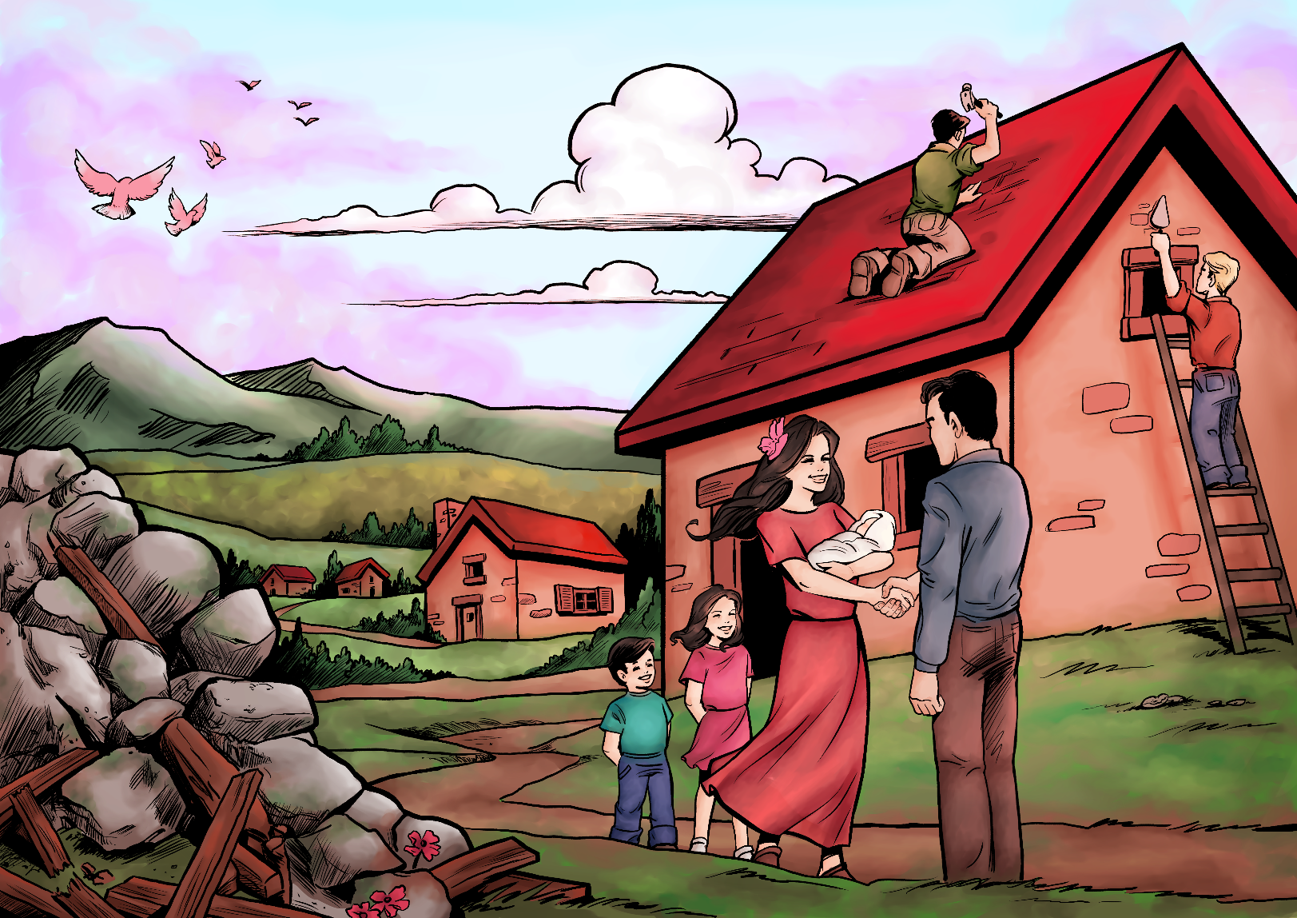

**Millennial Missions—Topic 9: Community and Caring**

**What God’s way is, and what He promises to those that love Him and follow in His way:**

Honour the LORD with thy substance, and with the firstfruits of all thine increase:

So shall thy barns be filled with plenty, and thy presses shall burst out with new wine. (Proverbs 3:9-10)

**What God’s Word warned would happen, because people have chosen to disobey God and allowed evil into their lives:**

Because that, when they knew God, they glorified him not as God, neither were thankful; but became vain in their imaginations, and their foolish heart was darkened. Professing themselves to be wise, they became fools,

And changed the glory of the uncorruptible God into an image made like to corruptible man, and to birds, and fourfooted beasts, and creeping things.

Wherefore God also gave them up to uncleanness through the lusts of their own hearts, to dishonour their own bodies between themselves:

Who changed the truth of God into a lie, and worshipped and served the creature more than the Creator, who is blessed for ever. Amen. (Romans 1:21-25)

**What God tells us to do about the problem for now, until the time is right for Him to make everything nice on Earth:**

Honour thy father and thy mother: and, Thou shalt love thy neighbour as thyself. (Matthew 19:19)

Finally, be ye all of one mind, having compassion one of another, love as brethren, be pitiful, be courteous: For he that will love life, and see good days, let him refrain his tongue from evil, and his lips that they speak no guile: (1 Peter 3:8,10)

**What might it be like on Earth during the 1,000 year time at the end of this world’s History, when the world is renewed and refreshed and Jesus Christ rules as King over all:**

Yet have I set my king upon my holy hill of Zion. I will declare the decree: the LORD hath said unto me, Thou art my Son; this day have I begotten thee.

Ask of me, and I shall give thee the heathen for thine inheritance, and the uttermost parts of the earth for thy possession. Thou shalt break them with a rod of iron; thou shalt dash them in pieces like a potter's vessel.

Be wise now therefore, O ye kings: be instructed, ye judges of the earth. Serve the LORD with fear, and rejoice with trembling.

Kiss the Son, lest he be angry, and ye perish from the way, when his wrath is kindled but a little. Blessed are all they that put their trust in him. (Psalm 2:6-12)

Mercy and truth are met together; righteousness and peace have kissed each other. Truth shall spring out of the earth; and righteousness shall look down from heaven.

Yea, the LORD shall give that which is good; and our land shall yield her increase. Righteousness shall go before him; and shall set us in the way of his steps. (Psalm 85:10-13)

And they shall build the old wastes, they shall raise up the former desolations, and they shall repair the waste cities, the desolations of many generations. (Isaiah 61:4)

**Promises for Princes and Princesses of God:**

But ye shall be named the Priests of the LORD: men shall call you the Ministers of our God: ye shall eat the riches of the Gentiles, and in their glory shall ye boast yourselves. (Isaiah 61:6)

Then came the first, saying, Lord, thy pound hath gained ten pounds. And he said unto him, Well, thou good servant: because thou hast been faithful in a very little, have thou authority over ten cities. And the second came, saying, Lord, thy pound hath gained five pounds. And he said likewise to him, Be thou also over five cities. (Luke 19:16-19)

He that overcometh, the same shall be clothed in white raiment; and I will not blot out his name out of the book of life, but I will confess his name before my Father, and before his angels. (Revelation 3:5)

To him that overcometh will I grant to sit with me in my throne, even as I also overcame, and am set down with my Father in his throne. (Revelation 3:21)

***

**Millennial Missions Stories**

*Imaginary Stories—taking place in the future time of the one thousand year “Millennium” that the Bible speaks of, when Jesus Christ rules all with love and justice, and the Earth is made pleasant again.*

* **Story 1--The Sad Old World: Removed From Home and Loved Ones**

Sanchez sat in his crowded prison cell, far removed from home and loved ones. It all started when he was young and a friend taught him how to steal petty items from a shop. Since he didn’t get caught—at least not all the time—this soon became an addictive and sad part of his life. He thought it was the solution to the money-driven world.

“If we don’t need money to get the things we need, then we’ll never have troubles,” he thought. Although part of the idea was good—that a money- driven world does cause troubles and stress, at the same time his way of being “free” would lead him to bondage.

He could never feel totally at peace. The fear that started in his heart was there right from the start, at the time he stole his first item. Sanchez could hardly remember a time when he felt truly peaceful.

Sometimes he had looked at other poor people in his city, those who were honest and didn’t try to steal from others, and he wished he could have the peace they had. His choices had made things worse for himself. The fear and constant nagging feeling that he was going to one day be found out, was making things miserable.

Well, at last the day came when he was found out, and oh did he wish he could go back in time and re-live his life a better way. He wished he could do it all over again, and this time make the right choices to help instead of hurt. To give, not just try to get.

Now he had all the time in the world to re-think things. There wasn’t much else to do but to think, and hope to survive this ordeal. Not everyone in the prison with him was as kind and calm as he was. They couldn’t manage the situation and would lash out in anger and hurt the others.

“What we need is training!” Sanchez realised one day. “It’s not enough to pull a guy off the street. He’s no better for it, when it’s the heart and mind that need re-wiring.”

Sanchez began to make request after request for someone to come to their prison to teach them better ways of living; someone who could give them hope of a better existence. Most of them hadn’t learned much else but the way of living that got them into here in the first place.

Finally, when good change in the prison situation was taking far too long to happen, while waiting for “free” people to try to find time in their schedule to help those who were bound, Sanchez thought it was time to pray—to a God He hoped was around and would take notice of him.

“Lord God, I’ve gotten myself into a mess. Now even if I want to live a good life, I can’t do it. I’m stuck here, and I’m stuck without knowing how to survive in the world without just trying to take from those who have too much. Help us out of this situation.

“If you help me and send someone to teach me how, then I promise I will do the best I can to make an improvement on as much of the world out there as I can—if or when I get out of here.”

The next day a new prisoner was sent to their cell. This man had been lied about and convicted of all kinds of false charges. At first the men were worried about having such a criminal in their midst, but as soon as they met him, he seemed very different from what was being said about him. Indeed there was something very different about him. He was calm, polite, and radiated a cheery light when he smiled.

“What was done falsely to me that landed me in this place, doesn’t matter right now,” he said. “What matters is that God has sent me here to be with you all. And for as long as I am stationed here, I will be a teacher to whoever wants to learn something new.”

At first the men jeered and made comments and jokes about the types of things he could be teaching them—and that those classes would make them greater criminals than ever. But when the commotion settled down, Sanchez spoke up.

“I prayed to God yesterday, for a teacher to be sent. There is so much I want to learn, so that I can build a new life once I get out. If you happen to know the right things that will help me, then I’m willing to listen.”

And so, right then, Sanchez received his first class, and soon just about everyone else in that crammed cell became interested too. It gave them something new to think about. He started telling them amazing true stories that had happened to him and his friends, while they lived and worked for God, helping others.

He told them about the way to Salvation, how to be truly forgiven by God, and to know peace at a last. He offered to pray with anyone who wanted to find forgiveness and be accepted in God’s family as His son. The men bowed their heads and accepted Jesus Christ into their life.

The former missionary taught them verses from the Bible that he had memorised, and soon many of them would quote them daily, committing them to memory. He could pray with them and for them, and soon many of their illnesses and pains began to heal. A miracle was happening right in that prison cell.

He told of the tremendous ways God would provide for him and his friends, without having to reach low ways to get the money—not just the low ways of poor thieves, but the low ways that the rich also were using to get from others to increase in riches themselves.

With God as his boss, they never lacked, at least not for long. And with their focus on feeding the hungry, both physically and spiritually, their hearts were joyful.

This man had taken time ever day to read and study the Bible, and it showed him the way to lead the best kind of life; a life that pleased God, and made him happy too. --That is until it was taken away, along with everything else, and he was locked in this prison on false charges.

It seems that his work with the poor was causing some people to lose business, as they were targeting those folks for selling their illegal and highly addictive substances to.

But knowing that the Lord can work things out for good, he trusted that there was a reason for being here. When Sanchez said that he had prayed for someone to come and teach him better ways to live, the man knew why he was here.

It was only three months that they all had together, as after that, the case was exposed as being a fraudulent attempt to clamp down on this good-doer, and the man was released. And wonderfully, soon afterwards, so was Sanchez.

He met up with the city missionary soon afterwards, not wishing to partake of his old life in any way. And before too long was kept very busy helping, teaching, and bettering the lives of others. He was able to get a job at the very store he had often helped himself to, wrongfully.

He decided that he would give a portion of his wages to buy things from that store, and then give these items to the missionary to use in his work—the work that Sanchez was working on too.

He helped to secure good deals for supplies to stock the shop, and posted ad’s around town to attract new customers. He did this when he heard the shop, that helped to hire destitute people to work there, was at the point of being shut down.

It was nearly going out of business trying to keep up with the high prices of supplies, and the recently raised sales taxes. But because he helped to do his part, people were able to be provided for, and the shop could keep going.

In time, Sanchez became the manager, and made sure that the only people he hired to help were those that were the most in need. He knew how to spot the youth that were attempting to take supplies, and rather than being harsh on them, he gave after-hours classes, teaching all the things he had learned about how to live a decently life with God as the main supplier, and helping others as the main goal.

He became known as “Sanchez the Saint” by some. He laughed at such a humorous yet honourable title, and knew it was God’s mercy and grace, and the faithful teaching of a fellow man who helped give him a new start to life.

After about 10 years had passed, the faithful elderly missionary said it was time for him to move on as there were others that needed him. And although it was hard to go, he knew that Sanchez would do a great job helping to keep things going. And he was right. For because he had been training a whole team of youth in the area, he now had a team ready and able to take over the work of the old missionary.

Things only got better from then on—because more people were helping and letting God be their boss and primary provider.

* **Story 2—The 1000 year Reign of Jesus Christ as King over all the world: Things Were Different Now**

Tears ran down the cheeks of the middled aged man, who sat precariously on the cliff overlooking the valley below. This was his place for thinking and trying to mentally process the memories he had from the old world. Times had been tough.

As he saw it, humanity had been chained to dance around the need for money in some way. This alone caused so much heartache.

His great-uncle had been forced to work mercilessly in the mines when he was young. At least that is what he was told. He never did get to meet him as he met with a very early end to his life.

The streets were roamed by criminals where his father grew up. Nowhere was safe since everyone was wanting to get, to take, to have, mostly in the hopes of having something to satisfy their empty hearts and troubled spirits.

What used to be a nice city turned to a wreck. His father’s troubles caused him an untimely end too, as he turned to drink to cover up the pain and fear he dealt with each day.

This man had to grow up on his own, living mostly on the streets, as his mother collapsed mentally due to the stress of life and trying to make a living. How he got this far, he didn’t know. He knew there should have been a better way, a new way. If only the world had been taught it!

At least things were different now in the world, if not completely better yet. Healing of hearts took time, and changing in habits—and a new and fresh generation of children took time to be raise and grow and then start making things much better in the world.

There was hope at least, with King Jesus in charge. There were so many questions he had.

“It’s a lovely view from up here,” a warm sounding voice was heard.

Edward turned his head to see a man making his way over. Soon this Heaven-sent visitor was seated beside Edward, and was ready to listen.

For a long while Edward was able to speak and unburden all that was on his heart. It had been kept in for so long, as there didn’t seem to be anyone with answers, so why ask? But it was different with this new friend. As Edward talked, he cried and just let it all go—let go of his sorrow, pain of heart, and confusion.

The answers and explanations and insight that this visitor had, helped completely change the way Edward was feeling. He walked away from that encounter having a new perspective. There was a reason behind each thing that had happened, and most importantly there was a great plan for the future.

Before leaving, the man handed Edward a little book. It was a collection of passages from the Bible all about having the right priorities, what really mattered in life. If he studied it and really understood what it was saying, then this would start a process in his own mind that would help bring about good change and positive behaviour in his own life, and in those he taught these principles to.

Edward had hope, and his heart felt so much lighter.

He didn’t see just where the man went. It almost seemed as if he vanished. Edward wasn’t yet acquainted with the abilities of the Heaven-sent messengers, but in time he would be. There was much to learn, and much to move on past.

When Edward got home he pulled out this booklet and began to make the first of many readings. The more he read, the more he knew he would like the new ruler and His ways. Something about it made his heart warm and excited at the same time. It was like getting the answers to what he wished that he and many others could have learned years ago.

It wasn’t that it was hidden away, for where he was living he had access to Bibles. But it had been lost in the rubble of all the other things he and others felt were more important. But now, with all the rubble taken away, there was lots of room in life to focus on the right things, God’s new way of living.

Edward’s mood had picked up and now it was easy to see things from a new perspective, and to see all the good in his situation.

The people around in the area were decent and caring people. He could see them getting along and working to build a new life on the broken remains of the old world. His health was better than he thought it would be at his age. He no longer had to work at a pointless or harmful, job to get money to pay for all the things he needed to be able to keep working and living to earn money to pay for all the things... and on went the loop. He was now free.

The land was free to live on. King Jesus only wanted happy, peaceful citizens that read and respected His Word, and cared about each other. They didn’t need to pay large parts of their income. There was no income, but all would need to work on this or that to help one another get by.

There weren’t thieves, as what would they steal? Food was available, in the wild, much of the time. Money wasn’t used or had no value—perhaps only as a museum piece. People now valued the important things—building a better world where love was the rule and faith in God was the strength of life.

The more Edward thought about it, the more he was liking the freedom that was known. They were free to learn the truth at last. There was hope that because of this, the new world would be many times better than the old one that was built on so many false ideas and greed, and lies.

Truth was all Edward hungered for, and just what King Jesus was very intent on providing to each one living now on Earth, and to the many that would yet grow up in this new environment.

After a week of reading and rereading that booklet, Edward could at last smile, really smile for the first time in so very long. Next, he began singing, just while he worked around the town, trying to make a few places for people to work on their skills and hobbies. The singing was coming from his heart. God’s Word and love had worked loose so many of the troubles in his heart. He felt like a new man.

Soon afterwards a team of Heavenly messengers came to his town to help out. They had great ideas and plenty of Heavenly backing to get all that was needed to set things up.

If there was at least one person in a town that loved God, wanted King Jesus to rule, and was reading God’s Words, then that is where these special teams of helpers were sent. Those were the places that received Heaven’s support. And things just got better and better from there on.

If the people in a place chose to go against the loving way the King wanted to make things in the world now, then they received little to no assistance, but were given time to reconsider, time to listen to those visiting who could tell them why it was important to live in the new ways of Heaven.

If they chose God’s ways, they could have lovely homes to live in, crops would grow well with all the needed rain, and extra special things would happen for them—like special parties with angels attending.

It was a time of learning for all, while the new world was getting set up, and each one learning that the first step to a joyful life, was to listen the first time to what God said to do, and then to wisely do it, and refuse to believe any fables that just weren’t so.

Edward found new joy and fulfilment in the tasks he seemed especially suited to do—helping to get others busy doing good for each other, and teaching classes of skills and needed trades. He finally felt like he was really living.

* **Story 3—Heavenly Ambassadors and Angels Living with Jesus Christ and Reigning with Him over the world: Back into Harmony**

“The time at last has come,” King Jesus said, holding a ring of keys in His hands. “Time’s up, and into the locker he goes!”

A key was given to a strong angel, a loyal one, who was very devoted to the King Jesus. His mission was to lay hold on the biggest troublemaker and lock him up in God’s jail for one thousand years. There would be no getting out of it.

When King Jesus opens a door, no one can shut it. When He shuts one, nobody can open it. And that is just what was needed now. The world had enough messing up. Nature had enough troubles. The Believers who love Jesus had more than enough of harm done to them by this troublemaker in the realm of the Spirit.

When God says, “It’s enough!” that is the final say, and it is finished.

The world would at last be free from the disrupter and destroyer who did nothing but try to break down the works of the Creator, and see to it that all got as much punishment as possible. He wasn’t interested in people doing the right thing and obeying God, just as long as plenty of punishments and trouble were handed out, that was fine with him.

Now people were at last going to learn about the true and full love of God, their Creator. Nothing was going to stop the spread of the Good News, God’s message of love and Salvation to all in the world.

With the evil one in God’s prison, so much wrong vanished. So much good began to spring forth.

***

A team of people met to discuss how they were going to start rebuilding their lives and community. So much destruction had happened, and so much needed to be healed. This team of survivors, along with a few messengers from the Kingdom of God, were wanting to get things off on the right foot.

There was no government in place—but the one authority of King Jesus, and His ruling ambassadors. Eventually some responsible, kind hearted people on Earth could be trusted to help in a serving capacity, to bring some order to the land.

For now, these elderly ones were discussing, “What one or two elements of the old world do you think caused the most damage and breakdown of morals, and what brought the most harm?”

After thinking things through, they all, in one wording or another, said: “Greed, money, wanting what others have—and not caring if others have less.”

They all nodded with each other’s conclusions.

Thus was the decision reached that as they started to set up somewhat of a town, all elements and anything that resembled money, or taking, having more or having, less, who is better, and all that, were to be a thing of the past.

Then someone asked God’s Heavenly representative there,

“How do things work where you come from? Clearly it’s vastly different than the mess we all got into down here.”

Anchorage the Angel replied,   
“The one thing that was pushed aside in the old world and was replaced with the counterfeit and fake reality—is the most important element of life in God’s City: His Word.

“It is revered in the Heavenly realm like nothing else. Nothing stands in the way of God’s Word being listened to, remembered, and lived out. These are the conditions that all citizens must abide by—and do so happily. For God’s Word is what brings life and beauty. It is what created the original world you live in now; and it’s what will bring it back to peace and beauty again.

“If everyone honoured it as the most important, fascinating, trustable, element of life, things would nearly instantly get back into their rightful place again, back into harmony.

“The time of trouble is past and God’s word has ordained these thousand years of refreshing. Those who believe God’s Word, and act on what He says to do, will have the most speedy change in the right direction.

“It may not be quite like our Heavenly abode—at least not for now, but it’ll be a vastly different place than the old world it use to be, and far better than what it now is.”

These words were wise and sound, and well pondered.

Finally one man said, “So what is the first step?”

“Tomorrow,” Anchorage the Angel said, “I’ll send teachers to come and begin the instruction, starting at the beginning and working through, day by day, the most important things to know that God’s Word has said for humans on Earth to realise.

“If close attention is payed, I assure you, your community here will be thriving and flourishing faster than you thought. Life and real living all have to do with the treatment and the respect you give to the Word of God.”

“Tomorrow it is. We’ll be here!” said the new students, hungry for truth and beauty, healing and peace.

“Never too old to learn a new thing! I feel our life is just starting. I’m excited to find out what we’ll learn about tomorrow! See you at the first day at school,” said one elderly to the others.

With a new spring in their step they went off, eagerly anticipating the first day of their new life getting better. For the first time in a very long time they began to have those happy feelings, and together with the good feelings was a seed of trust and faith that King Jesus’ rule was going to be a good one.

**Written by:** Chariane Quille

**Illustrated by:** Philippe

 www.nurture-inspire-teach.com

