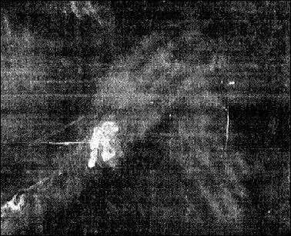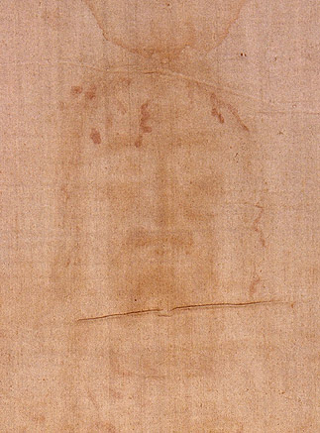

**July 14, 2019**

**You wanted me that much.**

**You bore gaping, torn scars, imprinted in Your transformed, Heavenly radiant body, all to show me that You wanted me that much.**

**I wasn’t just a thought, a wistful wish, a passing fantasy; something, someone You could take or leave, without an eternal consequence on Your supreme heart. You desperately, fervently, wanted me always with You.**

**In days of old, one who wished to promise forever to be a part of a family he served, he born in his ear the mark of a golden earring. A gold-filled hold showed his pledge of devotion and loyalty, out of love, for the one he served, and for his family.**

**But You, Who are the Lord, no servant, took the role of a servant and went much farther than that. You put aside Your ruling robes, and let Your enemies bore holes—not one, but many, in your flesh. Because you wanted me that much.**

**You let Your body show proof of the eternal love and devotion You had for me, Your humble servant—and yet for even those who cruelly wounded You...**

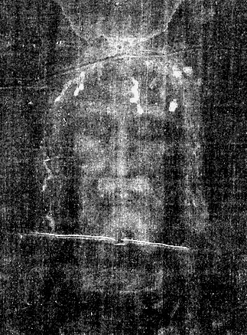**In one hand, then the other; in one foot, then the other; smiting you on one cheek, then the other. They wounded Your side near Your heart. Wound where on Your back, on Your head and on Your knees as they collapsed, fell, and were crushed with the weight of bearing the consequences of my waywardness.**

**Now as You gaze into my heart, You tell me: “I wanted you this much.”**

**And now my Lord, I kneel before You and look into Your eyes and cry out a prayer:**

**“Lord make me as brave as my love for You is. Brave enough to also endure the marks that will come as a consequence of loyalty to You. Gird me with strength and let the fire of love purge all cowardice from my feeble and shallow soul. Deepen my devotion so that when it comes my time to bear the wounds, as You said all who follow You would, I will not flinch, but rather rejoice in heart, anticipating the moment when I can at last look into Your heart and say, with love in my eyes, ’Lord, I wanted You this much.’”**

**Though my heart and mind and body be bruised, broken and scarred, I will find my perfect match in Your arms; held warmly with Your scarred hands. You will kiss away the hurts, and wash them with Your tears of gratitude; this display of my own wounds showing unfeigned evidence of my whole hearted and eternal devotion to You.**

**I will then kiss with grateful tears, each place You too, have borne a mark, a wound for me—all so You could say, so You could show me, that You wanted me that much! How much? Forever. And I am never to forget it.**

**Your Spirit became flesh so I could unite in flesh and spirit with You, in our new and wonderful transformed state.**

**Lord, I want You this much. How much? Whatever it takes; whatever it costs, to show You my love in the greatest way possible. We’ll have eternity to heal, to meld, and to hold one other.**

**Our fervent love—that we have demonstrated to each other in these ways—will be the healing balm.**